Lab 10 Changing Sampling Rate of Speech

OBJECTIVES

- Downsampling of speech with MATLAB
- Upsampling of speech with MATLAB
- Changing sampling rate of speech with MATLAB
- Verifying the polyphase implementations

PROCEDURE:

Part A: Down Sampling and Up Sampling

1. Given the data file “speech.dat” with 16 bits per sample and a sampling rate of 8000 Hz, design a decimator to change the sampling rate to 4 kHz.
Speech frequency range: 0 – 1800 Hz
Hamming window required for FIR filter design

The decimator scheme is given in Figure 1 below.

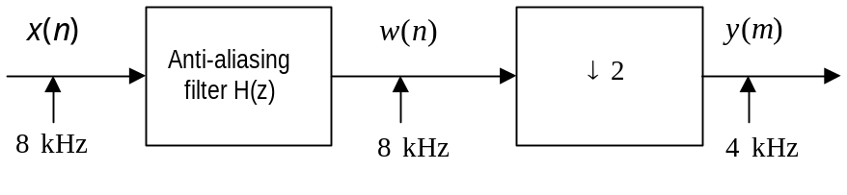
Figure 1

Complete the FIR filter design and print the frequency responses of the designed FIR filter.
Write a MATLAB program to implement the downsampling scheme. Notice that the MATLAB function for downsampling a vector w with a length of N and a downsampling factor of M is listed below:

MATLAB>y=w(1:M:N);

where y is the down sampled vector.

Verify the sound as follows:

MATLAB>sound(speech/max(abs(speech)),8000); % original sampling rate
MATLAB>pause
MATLAB>sound(your processed speech vector, 4000); % down sampled speech

Instructor verification __________________

2. Given the data file “speech.dat” with 16 bits per sample and a sampling rate of 8000 Hz, design an interpolator to change the sampling rate to 16 kHz.
Speech frequency range: 0 – 3600 Hz
Hamming window required for FIR filter design
The interpolator scheme is depicted in Figure 2 below:

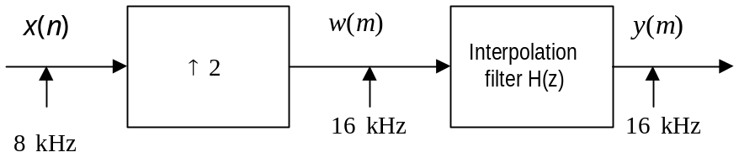
Figure 2

Complete the FIR filter design and print the frequency responses of the designed FIR filter.
Write a MATLAB program to implement the upsampling scheme. Notice that the MATLAB function for interpolating vector x with a length of N and an upsampling factor of L is listed below:

MATLAB> w=zeros(1,L*N);
MATLAB> w(1:L:L*N)=x;

where w is the up sampled vector.

Verify the sound as follows:

MATLAB>sound(speech/max(abs(speech)),8000);
MATLAB>pause
MATLAB>sound(your processed speech vector, 16000)

Instructor verification __________________

Part B: Changing Sampling Rate with Non-integer Factor

Given the data file “speech.dat” with 16 bits per sample and a sampling rate of 8000 Hz, design an interpolation and decimation algorithm to change the sampling rate to 22 kHz.

Speech frequency range: 0 – 3400 Hz
Hamming window required for FIR filter design

The scheme for changing sampling rate is shown below:

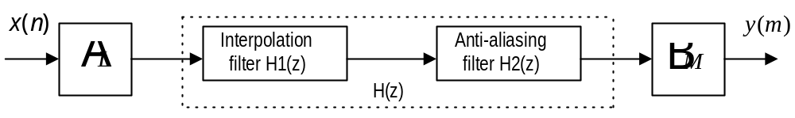
Figure 3

Determine the up sampling factor: L=
Determine the down sampling factor: M=
Complete designing the FIR filter (s)
Print the frequency responses of the designed FIR filter(s).

Write a MATLAB program to implement the scheme.

Verify the sound as follows:

MATLAB>sound(speech/max(abs(speech)),8000);
MATLAB>pause
MATLAB>sound(your processed speech vector, 22000)

Instructor verification __________________

Part C: Polyphase Implementations

Implement the decimator and interpolator in Part A using the polyphase implementations, respectively.
1. Decimator block diagram in its polyphase form is given in Figure 4.

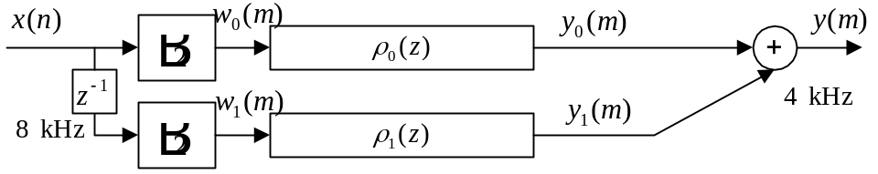
Figure 4

Write a MATLAB program to implement the decimator scheme and apply it to the speech data.

2. Interpolator block diagram in its polyphase form is shown in Figure 5.

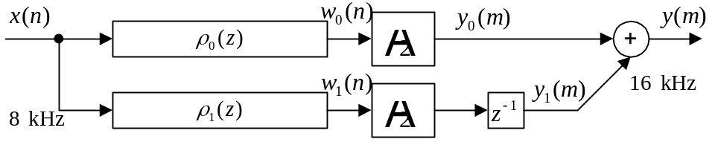
Figure 5

Write a MATLAB program to implement the interpolator scheme and verify it using the speech data.

Notice that the delay element can be implemented using the MATLAB function: filter().

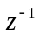: MATLAB> y=filter([0 1],1,x); % delay of one sample
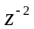: MATLAB> y=filter([0 0 1],1,x); % delay of two samples
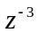: MATLAB> y=filter([0 0 0 1],1,x); % delay of three samples
…

Instructor verification ________________

